**Tripura**

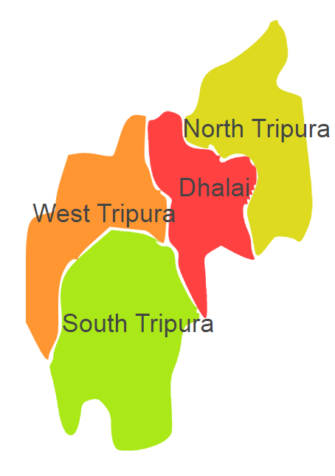

Tripura comprises of one Agro Ecological Region (AER) 17.

**Agro-Eco Region 17:** AER 17 in Tripura comprises of Dhalai, North Tripura, South Tripura and West Tripura districts of North-eastern Hills (Purvachal) under Agro Ecological Sub Region (AESR) 17.2.